-- Create the database
CREATE DATABASE university;
-- \c university;

-- Create the student table
CREATE TABLE student (
id SERIAL PRIMARY KEY,
name VARCHAR(100),
email VARCHAR(100) UNIQUE,
course VARCHAR(100)
);

-- Create the newStudent table
CREATE TABLE newStudent (
id SERIAL PRIMARY KEY,
name VARCHAR(100),
email VARCHAR(100) UNIQUE,
course VARCHAR(100),
created_at TIMESTAMP DEFAULT CURRENT_TIMESTAMP
);

-- Insert some values into the student table
INSERT INTO student (name, email, course) VALUES
('Alice Smith', 'alice.smith@example.com', 'Computer Science'),
('Bob Johnson', 'bob.johnson@example.com', 'Engineering'),
('Charlie Brown', 'charlie.brown@example.com', 'Business Administration');

-- 1. Trigger to insert into newStudent table after inserting into student table
CREATE OR REPLACE FUNCTION insert_into_newstudent()
RETURNS TRIGGER AS $$
BEGIN
INSERT INTO newStudent(name, email, course)
VALUES (NEW.name, NEW.email, NEW.course);
RETURN NEW;
END;
$$ LANGUAGE plpgsql;

CREATE TRIGGER after_student_insert
AFTER INSERT ON student
FOR EACH ROW
EXECUTE FUNCTION insert_into_newstudent();
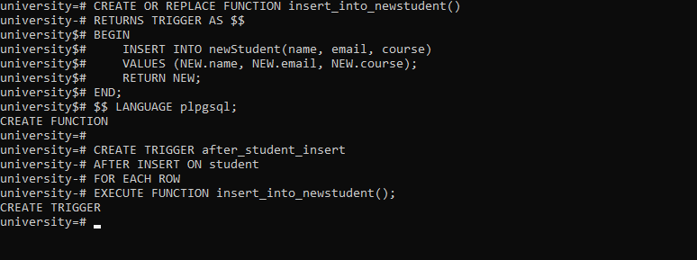

-- 2. Trigger to prevent inserts on Sundays
CREATE OR REPLACE FUNCTION prevent_insert_on_sunday()
RETURNS TRIGGER AS $$
BEGIN
IF EXTRACT(DOW FROM CURRENT_DATE) = 0 THEN
RAISE EXCEPTION 'Insertions are not allowed on Sundays.';
END IF;
RETURN NEW;
END;
$$ LANGUAGE plpgsql;

CREATE TRIGGER no_insert_on_sunday
BEFORE INSERT ON student
FOR EACH ROW
EXECUTE FUNCTION prevent_insert_on_sunday();
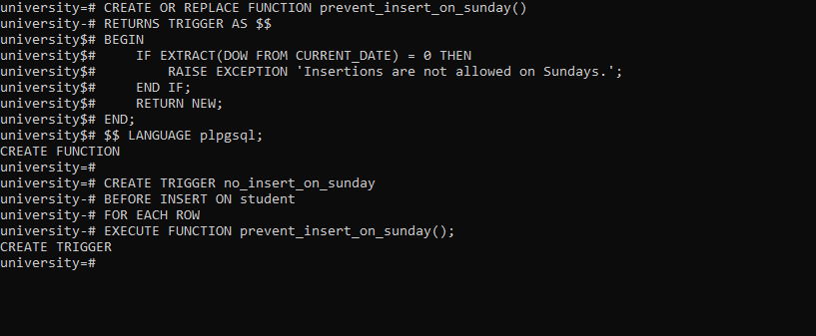

-- 3. Trigger to UPDATE the student record in the student table.
-- This trigger will update a field in the newStudent table when a student's record is updated. Let's update the course.
CREATE OR REPLACE FUNCTION update_student_record()
RETURNS TRIGGER AS $$
BEGIN
UPDATE newStudent
SET course = NEW.course
WHERE email = OLD.email;
RETURN NEW;
END;
$$ LANGUAGE plpgsql;

CREATE TRIGGER after_student_update
AFTER UPDATE ON student
FOR EACH ROW
EXECUTE FUNCTION update_student_record();
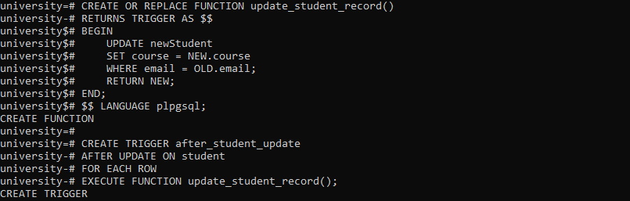

-- 4. Trigger to handle deletion of a student record in the student table.
-- This trigger will insert a record into newStudent table, marking it as deleted.
CREATE OR REPLACE FUNCTION delete_student_record()
RETURNS TRIGGER AS $$
BEGIN
INSERT INTO newStudent (name, email, course, created_at)
VALUES (OLD.name, OLD.email, OLD.course, CURRENT_TIMESTAMP);
RETURN OLD;
END;
$$ LANGUAGE plpgsql;

CREATE TRIGGER before_student_delete
AFTER DELETE ON student
FOR EACH ROW
EXECUTE FUNCTION delete_student_record();
